___________________________________________________________________________________________
Virginia Agricultural Experiment Station Bulletin 99-1
___________________________________________________________________________________________

Limited Arm-Rotation Shift-Trellis
(LARS) and Primocane Management
Apparatus (PMA) for Raspberries and Blackberries (Rubus cvs. or crops)

Herbert D. Stiles

Virginia Tech
Southern Piedmont Agricultural Research and Extension Center
Blackstone

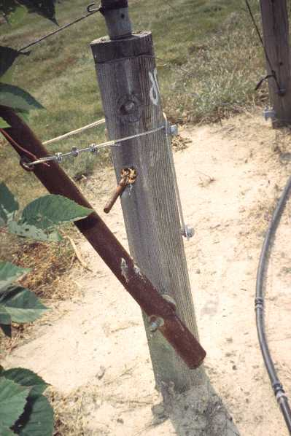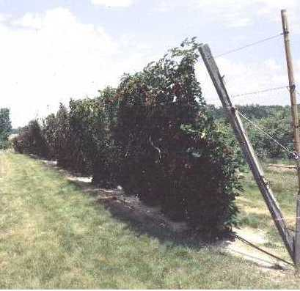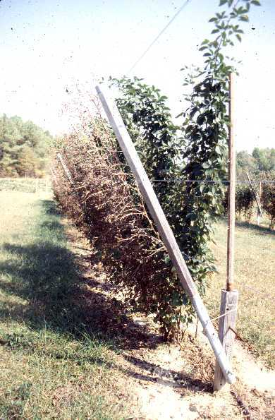

March 1999

This publication available at: http://www.vaes.vt.edu/research/publications/
TABLE OF CONTENTS

Page No.
TABLE OF CONTENTS i
List of Diagrams ii
List of Tables ii
Acknowledgments ii
Introduction 1
Primary differences between LARS and the SSST 4
Straight rows are essential for proper operation of all OSSTS, including LARS 5
Sequential procedures for building a limited arm rotation system trellis 5
Additional perspectives and suggestions on LARS installation procedures 7
Rationale of the new primocane management apparatus (PMA) 9
Installation and use of primocane management apparatus 9
Literature cited 26
Appendix 27

COVER PHOTOGRAPH LEGENDS

Upper left: LARS linepost with aircraft cable holding the crop-support arm in post-bloom configuration. The arm is 1.5" iron pipe; "blocking bar" (mid-post) keeps wind from shifting the arm.

Middle: Semi-erect blackberry floricane canopies in post-bloom positions on a 220-ft. LARS trellis. The crop-support arm is 3"x4" landscape timber. Primocanes are not yet present on horizontal twines of PMA (at right of photo).

Bottom right: Erect, thornless blackberry plants after the harvest season has ended on a LARS trellis. Leafless, spent, floricanes are on crop-support wires (left) and leafy primocanes are on PMA's twines at back side of the trellis (right). Crop-support arm and "primocane spar" are from different sizes of military surplus tent poles.

List of Trellis Diagrams and Tables
Fig. No. Page No.
1 LARS, A Shift-Trellis and Training System for Brambles, conceptual diagrams 3
2 Limited Arm Rotation System (LARS) Trellis 3
shown without primocane support apparatus
3 Pre- and Post-Bloom Positions of LAR's Crop-Arm Support Cable 4
4 Limited Arm Rotation System Trellis with 12
"primocane spar" and twine in place - perspective view
5 Limited Arm Rotation System (LARS) End-Post and Brace Assembly, 13
side view, with crop arm in vertical position
6 Crop-Support Unit from a LARS End-Post Assembly 14
with crop-arm in vertical configuration
7 LARS Crop-Support Arm for End-Post Assembly 15
8 LARS Line-Post Assembly with Primocane Spar 16
postbloom configuration (crop arm 25 deg. from vertical)
9 LARS Crop-Support Arm for Line-Post Assembly 17
10 Primocane Training-Spar for LARS Trellis 18
Tables
1 LARS Trellis - Materials for 1 End-Post Assembly in 210' Rows (Install 2 per Row) 19
2 LARS Trellis - Materials for 1 Line-Post Assembly in 210' Rows (Install 5 per Row) 20
3 LARS Trellis - Calculations of Crop-Wires and Tensioning Devices for 210' Rows 21
4 LARS Trellis - Bill of Materials for 1 Acre of Rows that are 210 Feet in Length 22
5 Materials for Primocane - Management Apparatus in 1 Acre of 210-Foot Rows 23
6 LARS Trellis - Bill of Materials for Rows that are 500 Feet in Length 24
7 Items for Installation of Primocane-Support Spars and Twine in 500 Foot Rows 25

ACKNOWLEDGMENTS
This work on trellising of blackberries and raspberries has been endorsed or sponsored by public and private non-profit agencies including: Virginia Agricultural Experiment Station, Virginia Cooperative Extension, Virginia Tech Southern Piedmont Agricultural Research and Extension Center, Virginia Tech Department of Horticulture, Virginia Agricultural Council, and Farmers Direct Marketing Association of Virginia. The author appreciates the varied forms of support and encouragement that were contributed by these agencies, other researchers, bramble producers, co-workers, and especially the author’s family members.

LIMITED ARM-ROTATION SHIFT-TRELLIS SYSTEM(LARS) AND PRIMOCANE MANAGEMENT APPARATUS (PMA) FOR BRAMBLE CROPS (Rubus cvs. or crops)

Herbert D. Stiles, February 17, 1999

INTRODUCTION

One-sided shift-trellising (OSST) and related training systems were originated as means of accommodating the biennial growth phases and habits of summer-fruiting raspberries and blackberries (Stiles, 1995a, 1995b, 1996). These systems manipulate the plant's canopy so that floricanes and primocanes are spatially separated from each other and their intra-canopy competition for sunlight is essentially eliminated. This manipulation also isolates the fruiting zone to one side of the trellis where fruits are readily accessible and easily harvested. Through such changes in the plant's configuration, air circulation within the fruiting zone and foliar canopies is freer so that fungus or bacterial diseases and fruit rots may be inhibited. With proper orientation of trellises and fruiting zones, certain OSST systems can be used to reduce sunscald and minimize the amount of "field heat" in harvested berries (Stiles and Tilson, 1998 abstract; Tilson and Stiles, 1998 abstract).
The original one-sided shift-trellis (i.e., the "Bent Fence" or SBF), is simple in design, composed of readily available materials, relatively inexpensive, and easy to operate. Thus, for a number of circumstances, the SBF remains a very viable management option. The later developed Single-Sided Shift-Trellis or SSST is somewhat more expensive to build and more difficult to operate than the SBF, but the SSST allows greater flexibility in canopy size (therefore yield?), greater uniformity in floricane canopy configurations or positions, and gentler treatment of canes during shifts from pre- to post-bloom canopy positions (Stiles, 1995a).
The "Limited Arm-Rotation System" or LARS (Fig. 1, 2) represents our latest refinement of OSST concepts. This system's trellis is simpler in design, less costly and easier to install than the SSST. Shifting of the LARS trellis's crop-support arms is a much easier task, and it can be accomplished in less time by fewer laborers than seem necessary for the SSST. Trellised floricanes are subjected to less acute bending during LARS' operations so cane breakage or injury should be even less likely than with the SSST. Existing SSSTs can be converted to LARS trellises, through modest investments of materials and labor, while preserving the continuity of harvests in established blackberry or raspberry plantations.
Various methods of primocane management have been proposed to facilitate annual, rather than biennial, cropping of brambles on SSST or similar trellises (Stiles, 1996). Such management would protect canes from injury and maintain free access to the planting for harvesters, pesticide applicators, etc. Subsequent experiences at Southern Piedmont Agricultural Research and Extension Center indicated that refinements or elaborations of primocane management procedures and apparatuses might be needed in order to facilitate annual cropping of erect and semi-erect brambles on both the SSST and LARS one-sided shift-trellises. Recognition of this need prompted the development and field trial of a Primocane Management Apparatus (PMA) that is described later in this manuscript.
Additional design modifications may occur and less expensive or better adapted construction materials may exist, but numerous producers, Extension workers and researchers in Virginia and other States have requested access to information so that local evaluations of LARS and PMA may be undertaken at an early date. Farmers have volunteered statements such as: "This is what I've been waiting for, now I'm ready to try it [one-sided shift-trellising]." This document includes diagrams and bills of materials to assist in the establishment of such trials. Similarly, the Appendix contains conceptual drawings of a single-wire LARS trellis that is being installed at SPAREC, in a new field study of raspberry cultural practices. This trellis may be even simpler to operate and less costly to build than current LARS versions, but the new work is needed to determine if this design is suitable for use with available Rubus cultivars, growth habits, etc.
Critical comments, questions, and suggestions for improvement of this offering, or of future efforts, would be greatly appreciated by the author. Reports on commercial trials of SSST or LARS trellises would be especially useful in evaluating the need for a continuation of this work.

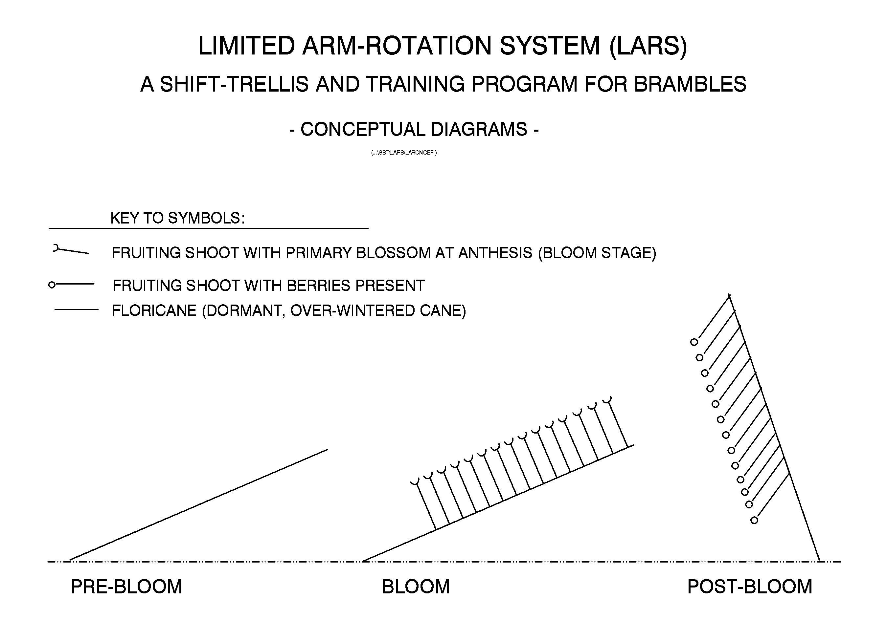
Figure 1.

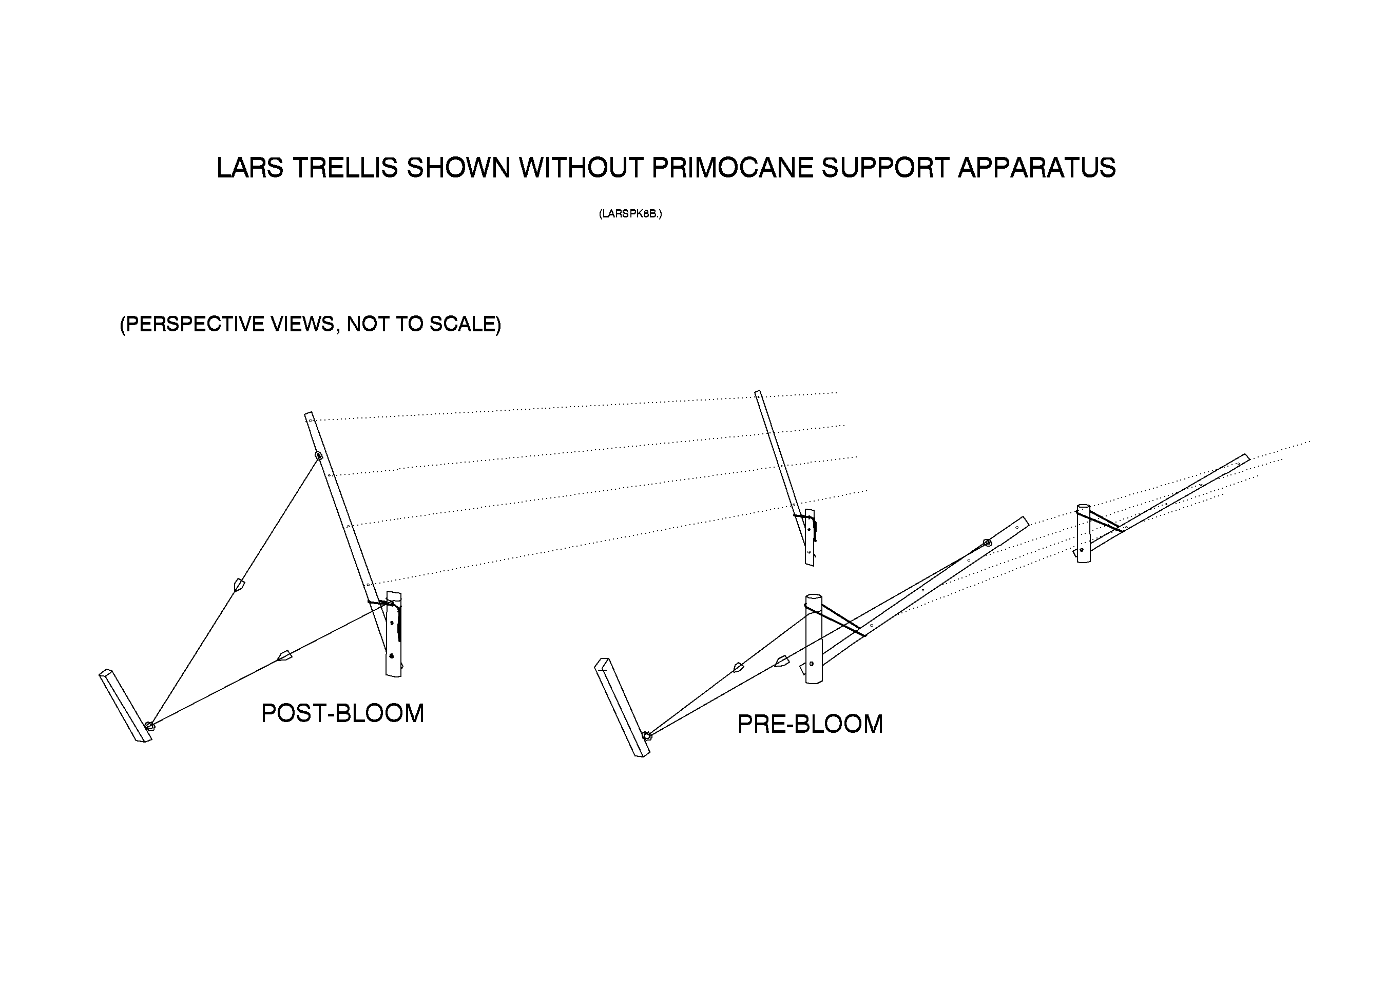
Figure 2.

Figure 3.
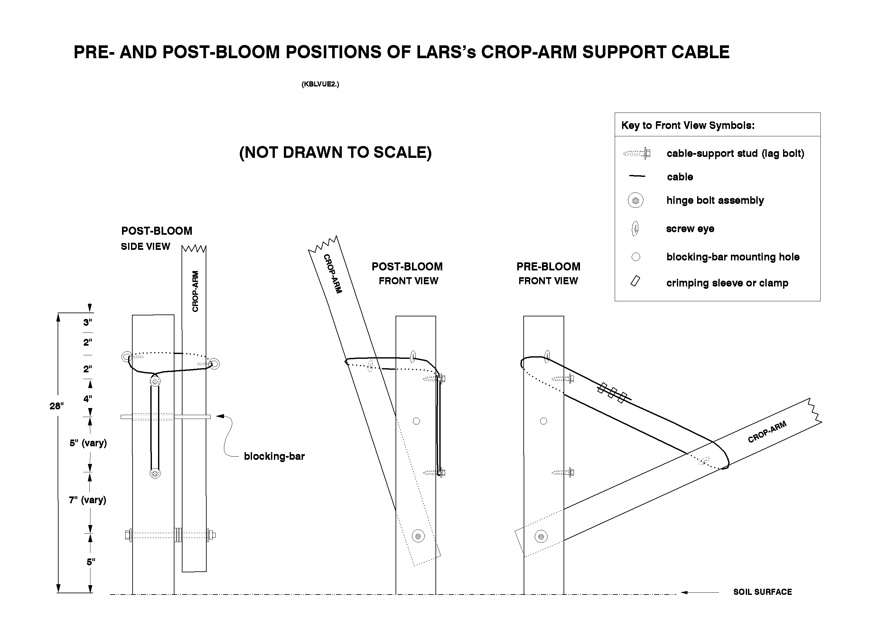

PRIMARY DIFFERENCES BETWEEN LARS AND THE SSST

LARS' design eliminates the need for a custom fabricated "flex-brace" so that all trellis components are widely available, "off the shelf" items. The redesigned crop-arm support apparatus (Fig. 3) is less expensive than the flex-brace and it greatly reduces the rigor, time and labor of crop-arm shifting procedures. LARS' end-post assemblies (Fig. 4, 7) are easier to install, and they require fewer materials, less skill, and less labor than the SSST's.
LARS operational procedures require only moderate bending (70°) of canes during movements of floricane canopies into pre-bloom and post-bloom configurations, so canes of brittle cultivars should be even less prone to breakage than in the older, SBF and SSST, systems. The LARS trellis' low pivot point, in combination with a newly devised "Primocane Management Apparatus, results in greater separation of floricane and primocane canopies so that sunlight reception and air movement may be increased, primocane quality may be improved, and removal of "spent-floricanes" may be facilitated (Fig. 4, 8, 10). Testing of PMA's effects has not been completed but a cooperating U-pick blackberry producer has been enthusiastic about its effects upon his enterprize's appearance and U-pick customers' access to the fruiting zone.

STRAIGHT ROWS ARE ESSENTIAL FOR PROPER OPERATION OF ALL OSSTS, INCLUDING LARS

Free and easy rotation of LARS' crop-support arms is fostered by the condition of "bi-lateral symmetry" that occurs when each row's in-ground trellis posts are carefully aligned. Trellis post alignment allows all the trellis' hingebolts to be placed on a vertical plane that extends through the row's two exterior braces or tie-back posts. With such hingebolt alignment, and proper construction of end-post assemblies, essential trellis dimensions can remain constant while crop-support arms are rotated from one to the other of the trellis' sides. Thus, re-adjustments in neither tensions nor lengths of crop-support wires or end-post brace-wires should be necessary when LARS trellises are shifted between their pre-bloom and post-bloom configurations.

SEQUENTIAL PROCEDURES FOR BUILDING A LIMITED ARM ROTATION SYSTEM TRELLIS:

1. Drive an outward-leaning (10-20°) tie-back post at each end of the row (Fig. 4, 5).

2. Use a string-line or sighting device and a surveyors tape or other measuring device to align and mark the sites where the vertical posts (4” diam.) of crop support units will be installed. The distance between an end-post assembly’s tie-back post and its crop-support unit (Fig. 4-6) is 11.5’; the distance between line-post assemblies (Fig. 4, 8) should be 25-35’ depending upon a particular row’s length, and the sites topography.

3. Install vertical posts at locations that were identified in the previous step (item No. 2). If possible, drill 2 ½” to 3” diameter, 3-4' deep pilot holes to facilitate the post driving task.

4. Use an off-set string-line to check post alignment and use the same string as a guide for strict alignment of sites at which hingebolts will be mounted in these posts (Fig. 3, 5, 7, 8). This string-line also can be used as a guide in marking the points at which vertical posts should be cut off or decapitated (Fig.3, 5, 6 ,8).

5. Drill 9/16” diameter holes through vertical posts at hingebolt sites that were determined in the previous step (item No. 4), then use a chainsaw or other tool to decapitate vertical posts at the prescribed height.

6. Drill pilot holes for, and install, the uppermost of two “cable-support studs” as illustrated in Figures 3, 5, 6 and 8.

7. Install pre-drilled crop-support arms and hingebolts on vertical posts. Be sure to install enough flat washers on the hinge bolt to provide 3/4” spaces between crop-support arms and the vertical posts to which they will be attached.

8. Drill holes in tie-back posts and install eyebolts as shown in Figure 5.
9. Cut a shallow kerf 1/3 of the way around the “back” of each end-post assembly’s vertical post (at 5 1/2” below the vertical post’s decapitation point) to act as a retainer for the brace-wire loop that will encircle this post (Fig. 5).

10. Install the lower and upper brace wires and tensioning devices in end-post assemblies as shown in Figure 5. Apply moderate tension to the lower brace wire but do not over-stress the wire or cause the crop-support unit’s vertical post to be displaced or bent.

11. Rotate the end-post assembly’s crop-support arm to a vertical position and preliminarily adjust the upper brace wire’s tension (this task requires participation of 2 workers). One worker operates the wire tensioning device while the other worker holds a 1”–thick, temporary spacer (wood or metal) in the gap between the vertical post and its crop-support arm in order to maintain the desired distance between these components. The second worker observes the crop-support arm and terminates brace wire tensioning activities before the crop-support arm begins to bend toward the tie-back post.

12. Begin to install the top-most (distal) crop-support wire by threading it through pre-drilled holes in the line-post assemblies’arms (Fig. 8, 9). When a sufficient length of the wire has been unreeled and threaded through line-posts to span the entire row, the wire’s free end should be wrapped around, and permanently fastened into position on an end-post assembly’s crop-support arm (Fig. 5, 7). Continue this installation by installing a wire-tensioning device on the wire, at mid-row, and fasten the wires remaining end to its end-post assembly crop-support arm. Apply slight tension to this wire by operating its mid-row tensioning device (Fig. 4) while tips of the crop-support arms remain in contact with the soil surface.

13. Conduct final tensioning of the top-most crop-support wire and end-post brace wires. This task will require at least 3 workers. Starting with the top-most crop-wire, one person operates the mid-row crop-wire tensioning device while co-workers at each end of the row hold the row’s crop-arms in vertical positions and monitor the end-post assemblies’ arms to ensure that they are not displaced from their necessary, strictly vertical, positions. The latter workers, or other helpers, may be called upon to fine-tune brace wire tensions in order to maintain the end-posts’ crop-arm positions. After final tensioning of these wires has been accomplished, rotate the trellis’s arms through a 180-190° arc (i.e., from one side of the row to the other) to verify that the desired ease and range of crop-support arm mobility has been attained. Absence of such mobility may indicate that brace wire and crop-wire tensions need re-adjustment or that improper alignment exists among the trellis’s hingebolts, etc.

14. The remaining crop-support wires may be installed as soon as item No. 12 (above) has been successfully accomplished.

15. The crop-support arms’ screw eyes must be installed before work with the arm support cables can begin, and availability of an “angle finder” will be necessary for the latter task.

16. Each crop-support arm’s support cable (aircraft cable) must be individually sized and fastened into a loop that will hold this arm at a prescribed “pre-bloom” angle of declination (usually 70° from vertical). This can be accomplished by passing the cable through screw eyes on the crop-support arm and “in-ground” post and, while the arm is held at the correct angle, empirically measuring the length of loop that circumscribes a tight ellipse around these two structures. The cable may be cut to the indicated length either before or after the necessary crimping sleeves or clamps have been installed (Fig. 3).

17. Proper positioning of the lower cable-support stud may be accomplished by moving the crop-support arm to its proper angle on the opposite side of the trellis, crossing two sides of the loop over the upper-most stud, and pulling the resulting “sub-loop” firmly downward. The second stud should be sited just inside the sub-loop’s lowest point.
ADDITIONAL PERSPECTIVES AND SUGGESTIONS ON LARS INSTALLATION PROCEDURES (the order of presentation does not imply differences in priority among these items):

1. Installation of posts to which crop-support arms will be attached (Fig. 3-6, 8):

a) Truly vertical orientation of in-ground trellis posts facilitates crop-support arm installation and it simplifies the task of shifting these arms between their "pre-bloom" and "post-bloom" positions (Fig. 1-3).

b) Use of round posts as the in-ground trellis components is recommended as a practical means of avoiding construction difficulties that may arise when posts rotate as they are being driven into the soil.

c) The vertical, in-ground post's decapitation height, blocking bar (brace-pin), and screw eye placements all should be determined on the bases of accompanying diagrams (Fig. 3, 5, 6, 8), after the post has been installed in the soil and its hingebolt's placement has been determined. The post's other features or attachments must be positioned on the bases of distances (measurements) from the hingebolt's location:

i) All of LARS' hingebolts must be located on, and aligned with the trellised row's centerline.

ii) All of a trellised row's hingebolts should placed on a flat, or gently curving (possibly undulating) "plane of elevation" that generally conforms to the fields topography.

iii) Accompanying diagrams specify that hingebolts are to be installed at an elevation of 5" but this is near the minimum height that will allow the bases of attached crop-support arms to pass unobstructed above the soil's surface. In rough-surfaced fields some posts probably will be located in soil depressions so that their bolts' axes may be several inches further from the soil surface.

f) Some variations in topography (i.e., elevation) can be tolerated where shift-trellises will be constructed, but the practical limits of such tolerance have not been ascertained.

g) Deep insertion (3' to 4') of line-posts seems important in preventing one-sided trellises from capsizing; this applies as much (or more) to static-trellises as to shift-trellises.

2. Proper alignment, construction and maintenance of end-post brace assemblies (Fig. 2, 4, 5, 6-7; Table 1), including tie-back posts and anchors, is critical for shift-trellis integrity and operation:

a) Tie-back posts must be deeply and firmly installed in the soil, by use of a post driver or by thorough tamping or cementing in place, before tension is applied to either the crop-support wires or the end-post brace wires.

b) The tie-back post's eyebolt must be installed so that its eye is aligned with the row's centerline and on the same horizontal plane as the end-post assembly's hinge bolt.

c) Brace-wire tensions (or lengths) must be adjusted, by use of in-line strainers (Fig. 5), so that the crop-support arm and "in-ground post" are perpendicular to the eyebolt/hingebolt axis. These tensions preliminarily are adjusted during installation of the end-post assembly, but they must be "fine-tuned" during subsequent installation and tightening of the crop-support wires (Fig. 4; Table 3).

d) Whenever crop-support wire tensions are being adjusted, it is critical that workers be assigned to monitor the end-post crop-support arms' positions and to adjust brace-wire strainers so that the arms' perpendicularity is maintained.

3. Crop-support wires should be mounted through holes in the line-posts' crop-support arms in order to avoid hazards that might arise if any wire(s) were to fail (break) during operation or construction of OSSTs; such a mounting technique seems more effective (than stapling of wires) in keeping the arms from twisting their hinge bolts.

4. Pre-drilling (with a drill press) of all necessary holes in crop-support arms (Fig. 7, 9) facilitates proper alignment of crop-support wires that pass through these arms so that tensioning of the wires is more easily accomplished. Pre-drilling also increases the speed and efficiency of field construction activities.

5. Sizing and installation of crop-arm support cables (Fig. 3):

a) Full tension should be applied to the distal crop-support wire before the lengths of crop-arm support-cable loops are adjusted at any posts within a row.

b) Lengths of crop-arm support cables must be individually adjusted for each crop-support arm in the planting. The necessary length of a support cable is determined while its associated crop-support arm is being held in the desired pre-bloom position and at the desired angle of declination (usually 70º from vertical).

c) Widely available, low-cost "angle finders" have been very useful (nearly indispensable), during installation of LARS crop-support arms, for adjustment of crop-arm declinations and support loop (i.e., cable) lengths.

d) A tool has been specially designed to aide in determining and marking the sites (on vertical posts) at which the lower cable-support stud must be located in order to achieve the desired angles of declination among post-bloom positioned crop-support arms.

6. A removable "blocking-bar" (9" x 3/8" brace-pin) is mounted in each vertical trellis post in order to prevent wind from moving crop-support arms out of their seasonally prescribed positions (Fig. 3, 6).

RATIONALE OF THE NEW PRIMOCANE MANAGEMENT APPARATUS (PMA):

Primocane Management Apparatus (PMA) was derived primarily to improve conditions for annual cropping of blackberries and raspberries on SSST and LARS trellises. PMA will help to protect primocanes from injuries by equipment, foot-traffic, or wind, and will tend to increase the degree of spatial separation between primocanes and floricanes. Greater canopy separation should increase the exposure of leaves to sunlight and allow freer air movement within both the primocane and floricane canopies. PMA coincidentally should assist producers to maintain orderly appearing plantings that may be more attractive to U-pick patrons or custom harvest laborers. Application of this technology may contribute to development of semi-mechanized procedures for removal of spent floricanes (i.e., old cane pruning).

INSTALLATION AND USE OF PRIMOCANE MANAGEMENT APPARATUS:

1. PMA's primocane support spars and twine should be installed after the trellis' crop-support arms have been shifted to their post-bloom positions:

a) PMA can be installed, or "retro-fitted," on existing SSST or LARS trellises, in established plantings, during the "post-bloom" period in any particular season.

b) The sequences of plant development, trellis arm shifting, and other events in new plantings suggest that PMA not be installed before the post-bloom period of a new plantation's second growing season. This suggestion, through delay of material acquisition and labor expenses, may allow the producer to reduce investment costs (i.e., interest payments) of new enterprises in which the use of PMA is anticipated.

2. PMA consists of detachable, disposable, polypropylene primocane-training twines supported by "J-hooks" or one-sided staples on rigid "primocane-support spars" (or extensions) that are removably mounted atop the short, vertical posts in LARS' end-post and line-post assemblies (Fig. 4, 8; 10 Table 5, 7):

a) Accurate positioning of J-hooks on primocane-support spars is needed to permit the primocane canopy to be transferred en mass from PMA to the trellis' crop-support-arm.

i) Small variations in LARS or SSST trellis dimensions (especially heights of vertical posts) may occur during field installation procedures and such variations may affect the exact positions at which J-hooks should be mounted along each primocane support spars' length.

ii) Proper J-hook positions will coincide with a trellis arm's crop-support wires when that arm is rotated into a vertical configuration, these positions can be determined after spars have been installed on trellis posts, by measuring their prescribed distances from the trellis posts’ hingebolts.

iii) Thus, each spar is considered to be uniquely adapted for use with the trellis post on which it originally was installed; posts and spars should be permanently marked so that their future pairings can be assured (see also the section on PMA use).

b) In order to achieve more effective adjustment of twine tautness, and to avoid undesired effects upon canopy positions, it is important that the specified tensioning devices be installed at or near their respective twines' mid-points rather than near the ends of the trellised row.

3. Use of the primocane management apparatus:

a) Depending upon a cultivar's growth habit (propensity for sucker production), its in-row plant spacing, and the morphology of its canes (particularly cane diameter), primocanes will be trained vertically or in fan patterns for attachment to PMA's horizontal twines.

b) Additional research is needed to determine the numbers or spacings of primocanes that may be needed for optimal productivity, etc., of the various types or cultivars of brambles that may be trained on this type of trellis; densities of 2 to 3 canes per foot of row seem appropriate for initial trials of this system.

c) Primocanes probably should be trained and tied to the PMA at weekly intervals during periods of rapid primocane elongation; labor costs of primocane training may be minimized by use of semi-automated tying tools or "tapeners."

d) PMA's twines may tend to stretch and sag during warm weather, or when subjected to the weight of attached primocanes, and their tautness must be adjusted just prior to each primocane training session. Laborers must be instructed to ensure that twines are positioned at their desired elevations during the act of primocane attachment. Such positioning will facilitate the eventual transfer of twines and canes onto the trellis's crop-support arms.

e) Primocane training-twines, not canes per se, are tied to the trellis' crop-support wires. This should minimize the dormant-season's training-labor and material requirements and facilitate the eventual, after-harvest, removal of these canes from the trellis.

f) During their transfer to the trellis' crop-support-arm, primocanes that are trained and tied to the twines' "inner-sides" will become sandwiched between training-twines and permanent crop-support wires. This juxtaposition should strengthen the canopy's attachment to crop-support wires so that wind will be very unlikely to dislodge canes from the trellis.

g) PMA's spars must be dismounted from the tops of trellis posts (after twines and canes have been transferred to crop-support wires) so that the trellis's crop-support arms can be shifted to their pre-bloom positions. Spars can be stored in situ, on crop-support wires at each spar's original crop-support arm location.

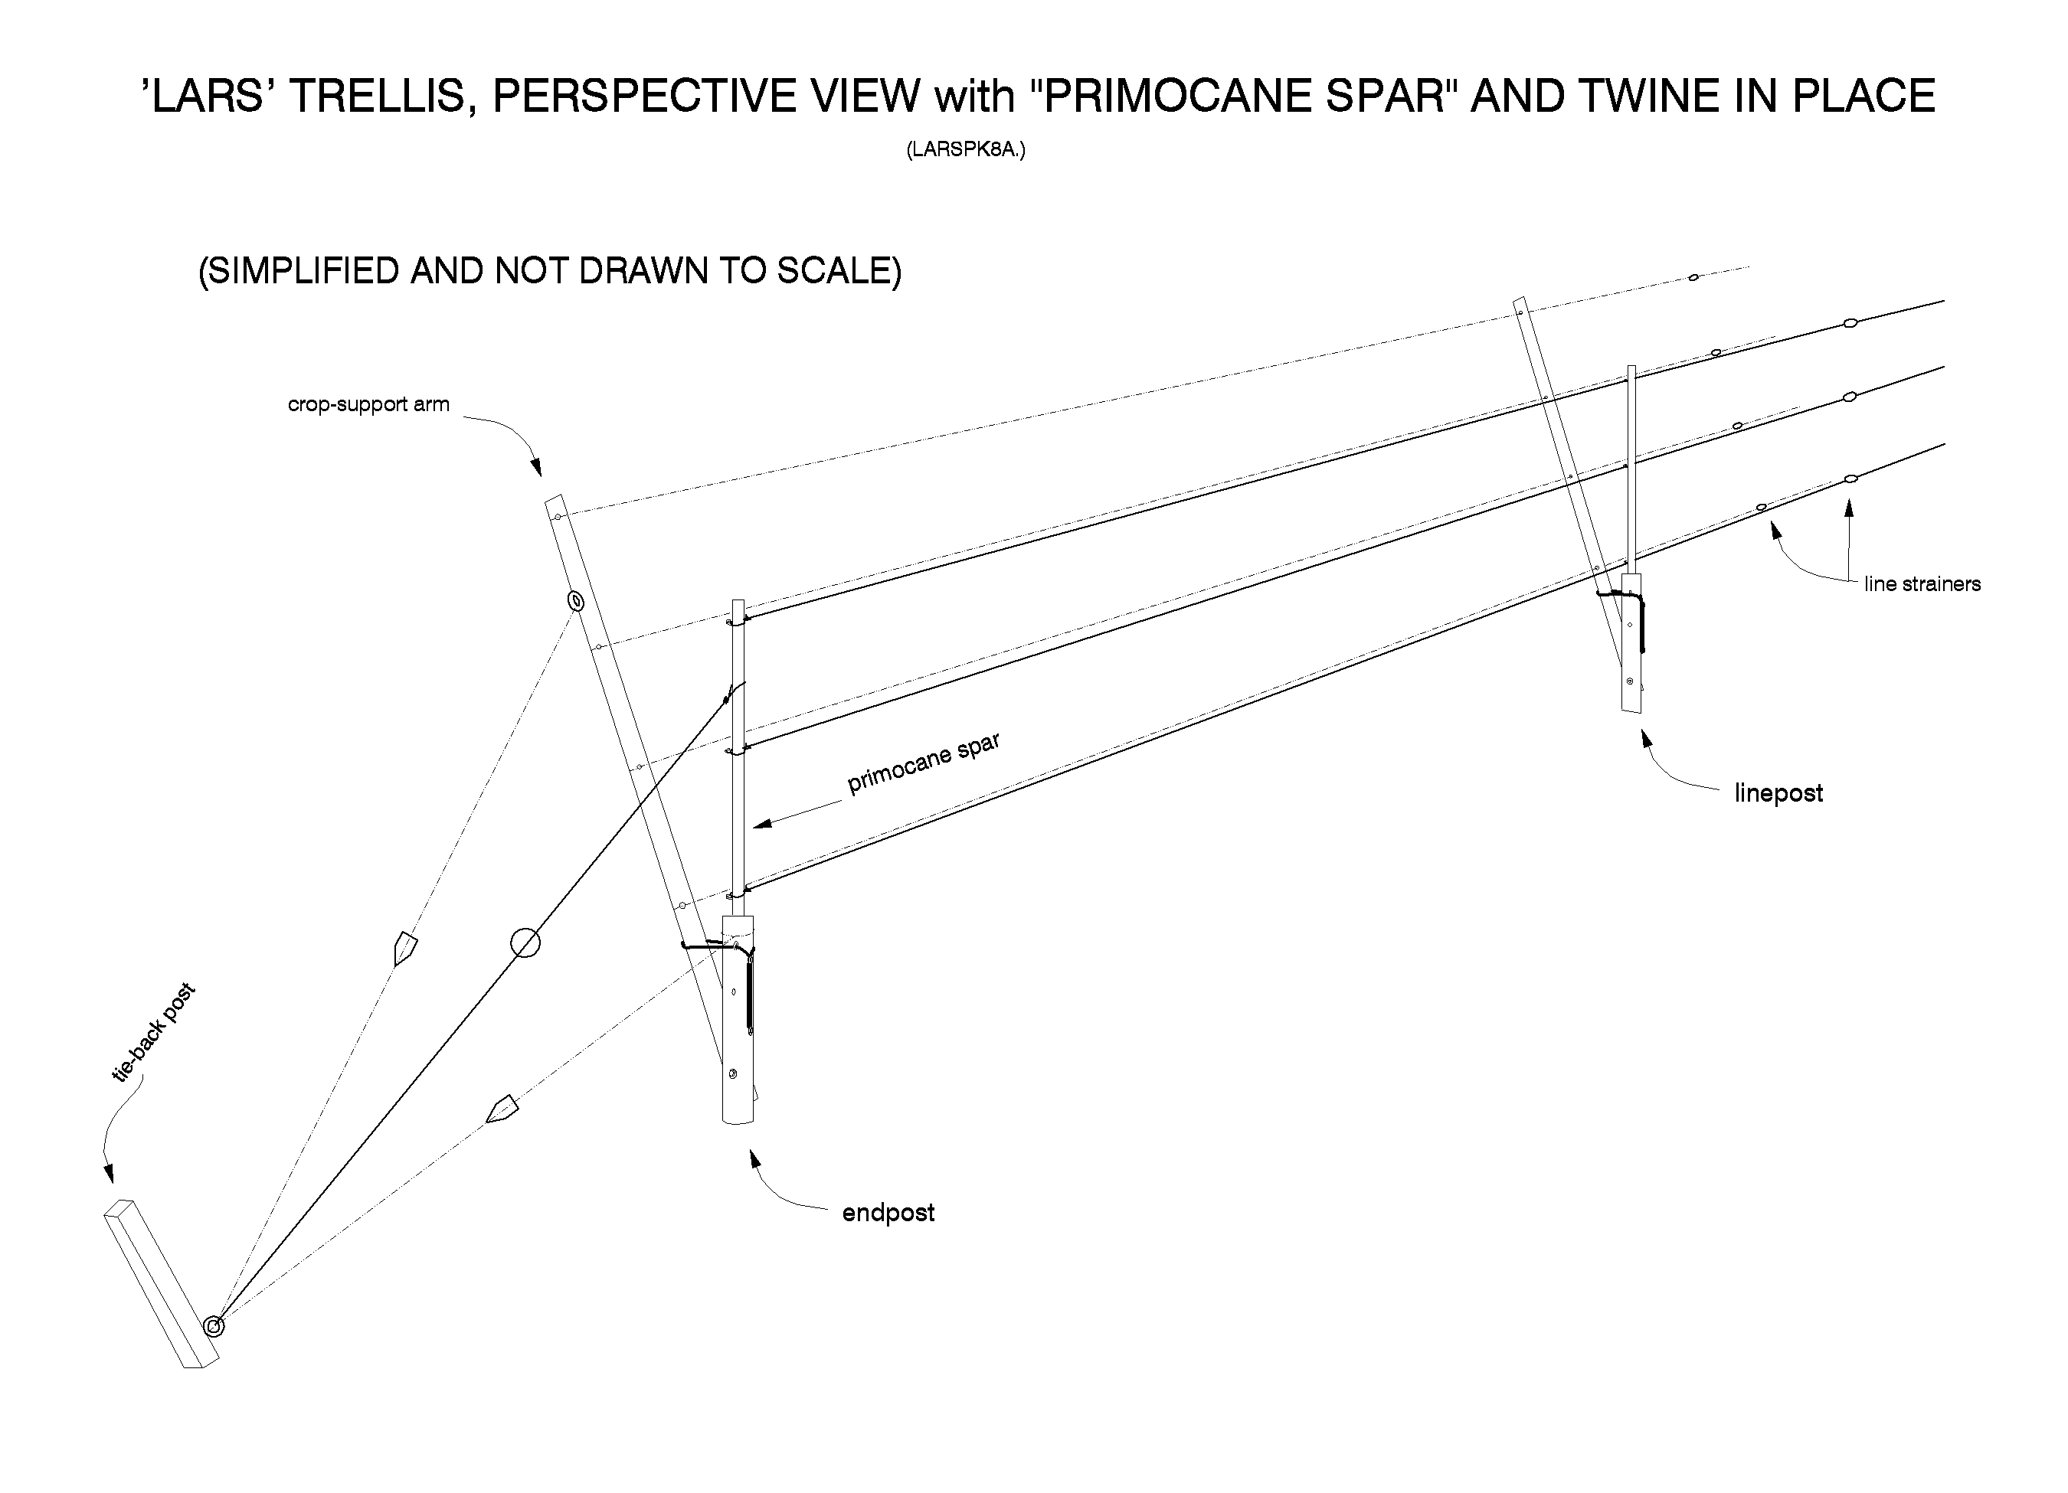

Figure 4.
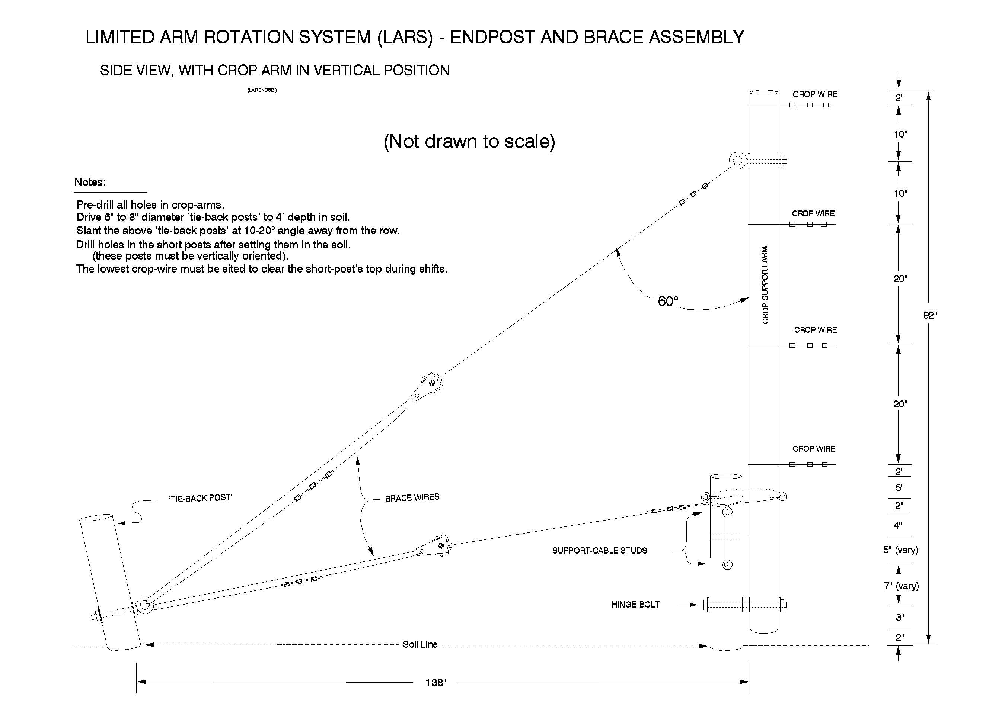

Figure 5.
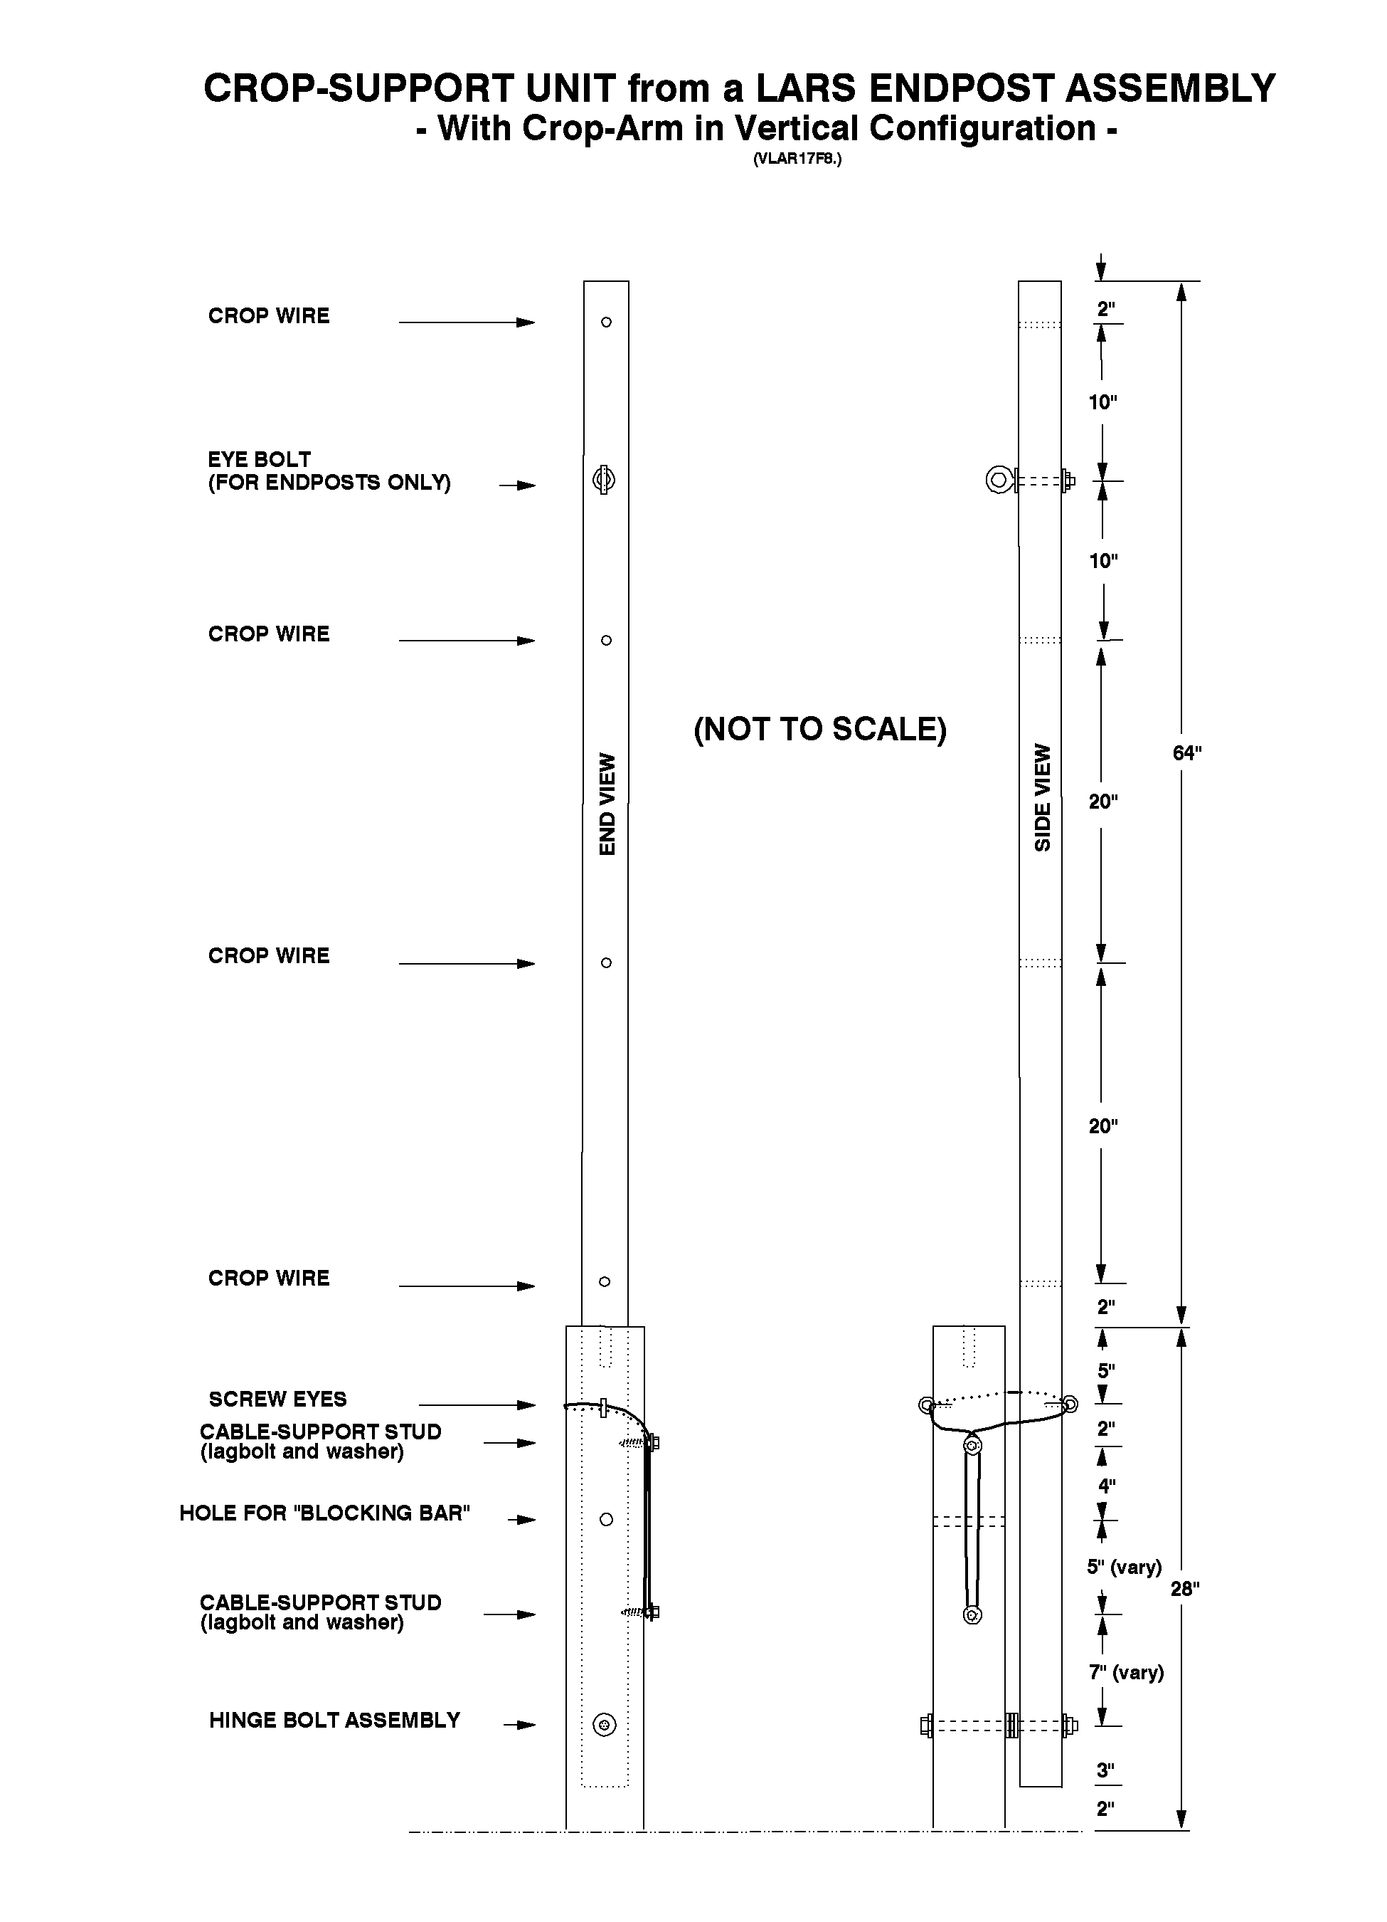

Figure 6.
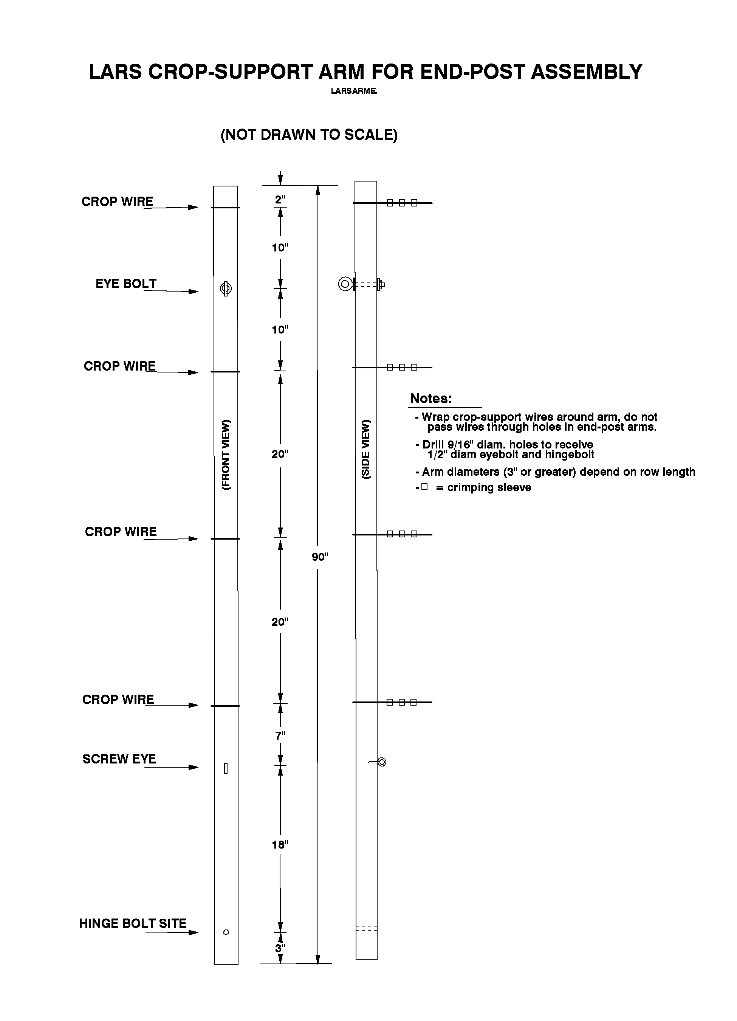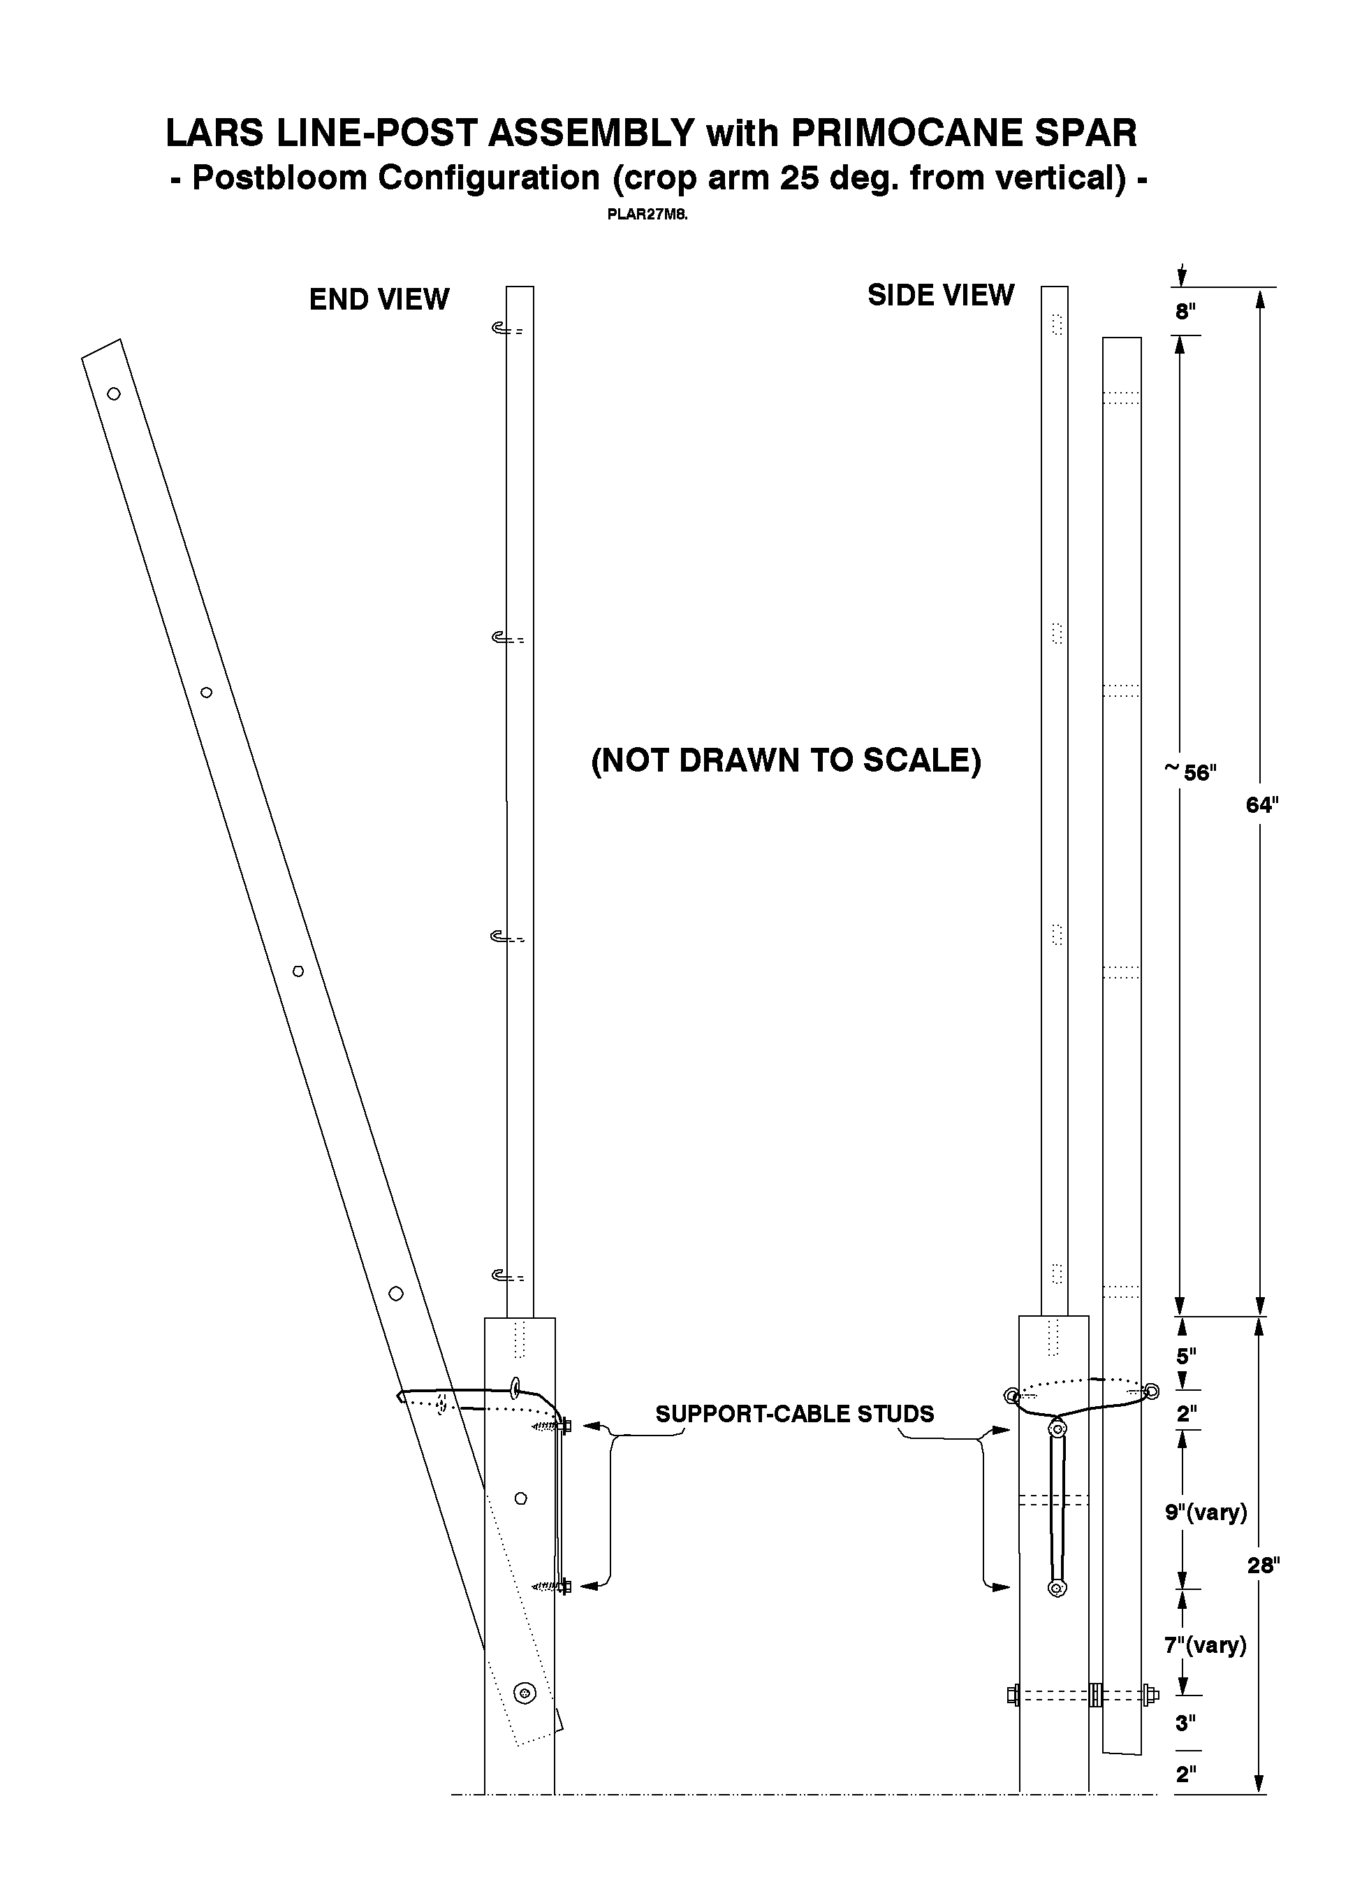

Figure 7.

Figure 8.
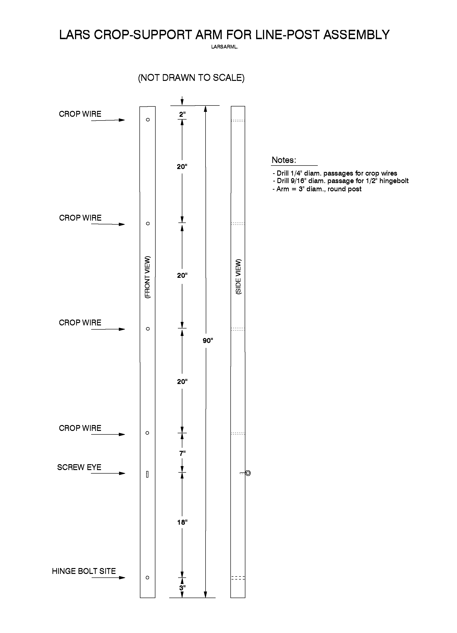

Figure 9.

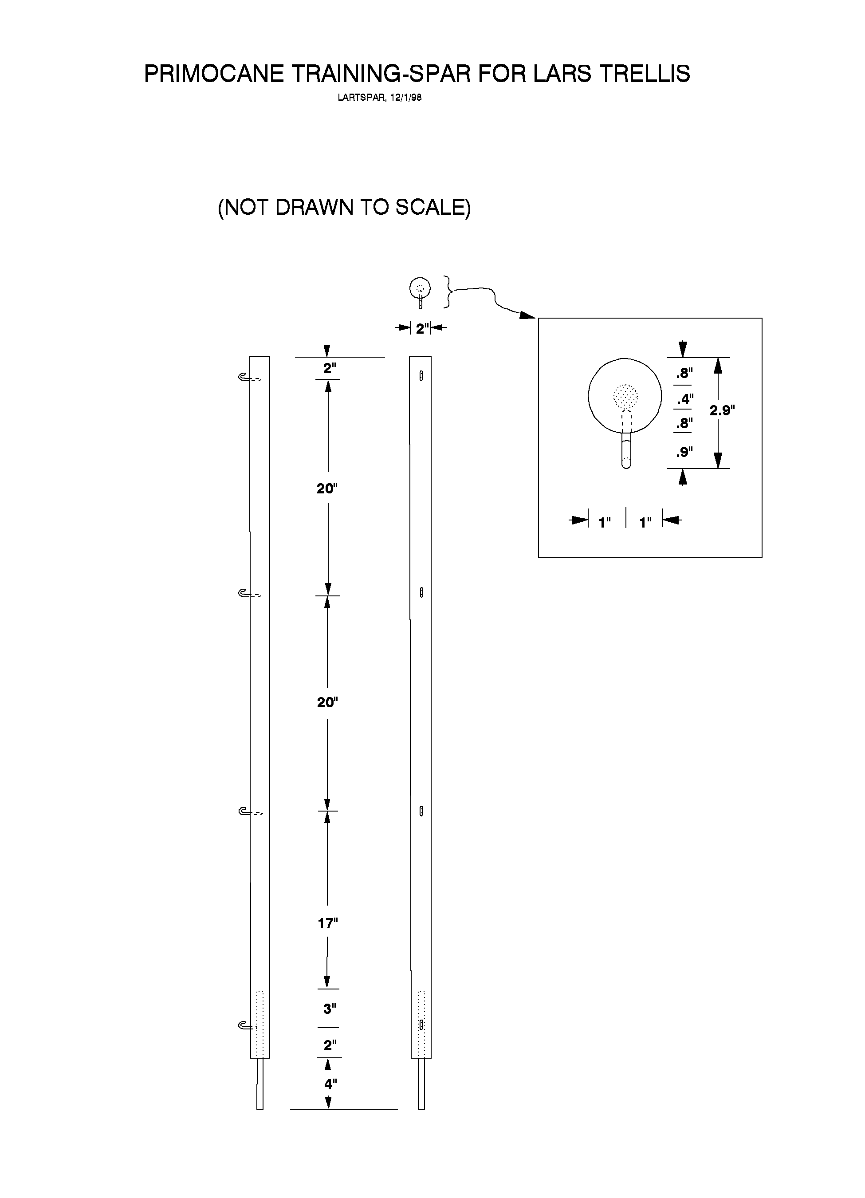

Figure 10.

Table 1. LARS TRELLIS - MATERIALS FOR 1 END-POST ASSEMBLY IN 210' ROWS (INSTALL 2 PER ROW):

Item | Description | units | cost/unit | total cost
1 | tie-back post; wooden, round, 6" x 8', CCA pressure-treated | 1 ea.
2 | vertical post; wooden, round, 4" x 8', CCA pressure-treated | 1 ea.
3 | crop-arm; wooden, round, 3" x 7.5', CCA pressure treated | 1 ea.
4 | bolt, 1/2" x 9" (or 10") shaft, 3" threaded length, zinc-coated | 1 ea.
5 | eyebolt, 1/2" x 7" shaft, 3" thread length; zinc-coated | 1 ea.
6 | eyebolt, 1/2" x 4" shaft, 3" thread length, zinc-coated | 1 ea.
7 | nut, 1/2" diameter, zinc-coated | 3 ea.
8 | flat-washer, 1/2" diameter, zinc-coated | 14 ea.
9 | lagbolt, 3 1/2" x 1/2", 2 1/2" thread length, zinc-coated | 2 ea.
10 | screw eye, size 0, zinc coated | 2 ea.
11 | aircraft cable, 1/8"diameter, 7 x 19 style, galvanized or stainless steel | 6 ft.
12 | NicopressTM crimping sleeve for 1/8" aircraft cable (or use cable clamps) | 3 ea.
13 | fence-wire crimping sleeve (NicopressTM, No. FW-2-3) | 24 ea.
14 | in-line wire strainer, galvanized or zinc coated | 2 ea.
15 | wire, 12.5 ga. hi-tensile, galvanized | 50 ft.
16 | brace pin 9" x 3/8", zinc-coated | 1 ea.
Total Materials Cost per End Post Assembly |  |  | ------- | -------
Table 2. LARS TRELLIS - MATERIALS FOR 1 LINE-POST ASSEMBLY IN 210' ROWS (install 5 per row):

Item | Description | units | cost/unit | total cost
1 | vertical post, wooden, round, 8'x 4" min. diam., CCA pressure treated | 1 ea.
2 | crop-arm, wooden, round, 7.5'x 3" min. diam., CCA pressure treated | 1 ea.
3 | bolt, 1/2" x 9"(or 10") shaft, 3" threaded length; zinc-coated | 1 ea.
4 | nut, 1/2" diameter, zinc-coated | 1 ea.
5 | flat-washer, 1/2" diameter, zinc-coated | 8 ea.
6 | screw eye, size 0, zinc coated | 2 ea.
7 | aircraft cable, 1/8", 7x19, galvanized or stainless steel | 6 ft.
8 | Nicopress crimping sleeves for 1/8" aircraft cable (or use cable clamps) | 3 ea.
9 | brace pin, 9" x 3/8", zinc-coated | 1 ea.
Total Materials Cost per Line-post Assembly |  |  | ----- | -----

Table 3. LARS TRELLIS - CALCULATIONS OF CROP-WIRES AND TENSIONING DEVICES FOR 210' ROW LENGTHS

Assumptions:
- The number of crop-wires per row should be chosen with regard to length of the crop-support-arm, cane morphology, etc. Four crop-wires probably are the maximum needed for most applications of this trellis, and this number is employed in the following tables.
- Crop-support wires include lengths that are needed to secure them to the end-post crop-arms, and to operate wire-tensioning devices that are installed at mid-row in each wire. Thus, the length of a single crop-wire = trellised row's length (from tie-back post to tie-back post) minus about 10 feet.

Calculations:
(1) Total Length of crop-wires (12.5 ga. hi-tensile, galvanized) per acre =
(No. crop-wires/row = 4 ) x (wire length/crop-wire = 210 ft. ) x (No. rows/acre = 20 ) = 16,800 ft. of wire/acre.
(2) Per Acre Cost of crop-support wire = ( ft. of wire/acre) x ($ / ft. of wire) = $ /acre.
(3) Number of crop-wire tensioning devices = (1 device /wire) x (4 wires/row) x (No. rows/acre = 20 ) = 80 devices/acre.
(4) Per Acre Cost of crop-support wire tensioning devices, = (No. devices /acre = ) x ($ /device) = $ /acre.

(5) Total Cost1 of Crop-support Wire and Tensioning Devices = (Item No. 2) + (Item No. 4) = $ / acre.

Table 4. LARS TRELLIS - BILL OF MATERIALS FOR 1 ACRE OF ROWS THAT ARE 21O FEET IN LENGTH ,

Assumptions: trellis row length = 210' (64m); endpost assembly length = 11.5' (3.5m); distance between the 2 endpost crop-arms = 187' (57m); at a crop-arm spacing of 31'(9.5m) there are 5 line-post assemblies/row. If 210-ft. rows are spaced at 10', each occupies 0.048 acres (20 rows/ac.) or 0.02 ha (51 rows/ha).

Item | Description | units/row | units/acre | cost/unit | cost/row | cost/acre

1 | tie-back-post, round, 6" diameter x 8', CCA pressure-treated | 2 ea. | 40 ea.
2 | end- and line-posts (vertical part), round, wooden, 4" x 8', CCA pressure-treated | 7 ea. | 140 ea.
3 | crop-arm, wooden, round, 3" x 7.5', CCA pressure-treated | 7 ea. | 140 ea.
4 | bolt, 1/2" x 9" (or 10"), 3" threaded length; zinc-coated | 7 ea. | 140 ea.
5 | eyebolt, 1/2" x 7" shaft with 3" threaded length | 2 ea. | 40 ea.
6 | eyebolt, 1/2" x 4" shaft with 3" threaded length | 2 ea. | 40 ea.
7 | nut, 1/2", zinc-coated | 11 ea. | 220 ea.
8 | flat-washer, 1/2", zinc-coated | 54 ea. | 1080 ea.
9 | lagbolt, 3 1/2" x 1/2", w/ 2 1/2" threaded length; zinc-coated | 14 ea. | 280 ea.
10 | screw eye, size 0, zinc coated | 14 ea. | 280 ea.
11 | aircraft cable, 1/8", 7x19, galvanized | 42 ft. | 840 ft.
12 | crimping sleeve for 1/8" aircraft cable (or cable clamps, if desired) | 21 ea | 420 ea.
13 | fence-wire crimping sleeve (NicopressTM, No. FW-2-3) | 30 ea. | 600 ea.
14 | in-line wire strainer, galvanized or zinc coated | 4 ea. | 80 ea.
15 | Gripple, standard (for 12.5 ga. wire) in-line wire tensioner | 4 ea. | 80 ea.
16 | wire, 12.5 ga. hi-tensile, galvanized | 900 ft. | 18,000 ft.
17 | brace pin 9" (3/8"" diameter), zinc-coated | 7 ea. | 140 ea.

TOTAL COST OF MATERIALS |  | ------- | ------- | -------

Table 5. MATERIALS FOR PRIMOCANE-MANAGEMENT APPARATUS ,, IN 1 ACRE OF 210-FOOT ROWS

Item | Description | units/row | units/acre | cost/unit | cost/row | cost/acre
1 | wooden spar (lodgepole pine?), 2" diameter x 64", CCA pressure treated | 7 ea. | 140 ea.
2 | dowel (zinc-coated, steel "brace pin"), 3/8" diameter x 9" length | 7 ea. | 140 ea.
3 | in-line/on-line strainer, plastic, (spec's ??) | 6 ea. | 120 ea.
4 | twine, polypropylene, 10 yd./oz., 130-170 lbs/bale knot strength | 900 ft. | 18,000 ft.
5 | one-sided staples (or "J-hooks"), 1 3/4" to 2" length, zinc-coated | 28 ea. | 560 ea.
TOTAL COST OF MATERIALS |  | ---- | ---- | ----

Table 6. LARS TRELLIS - BILL OF MATERIALS FOR ROWS THAT ARE 5OO FEET IN LENGTH ,

Assumptions: trellis row length = 500' (152.4m); endpost assembly length = 11.5' (3.5m); distance between the 2 endpost crop-arms = 477' (145.4m); at a crop-arm spacing of 34'(10.4m) there are 13 line-
post assemblies/row. If 500-ft. rows are spaced at 10'10", each occupies 0.124 acres (8 rows/ac.) or 0.05 ha (20 rows/ha).
Note that the tie-back posts' 8" diameter is larger than specified for shorter (210') rows, so their cost will be greater. Similarly, 4"-5" diameters are suggested for the endposts' crop-arms. The latter changes make larger bolts, eyebolts, nuts and flat washers necessary for use in the endpost assemblies; thus, 5/8" diameter items are all intended for use in endpost assemblies. It may be necessary to augment the endpost assemblies' wire braces and cables, but these possibilities are not reflected in the following bill of materials.

Item | Description | Description | units/row |  |  | units/acre |  | cost/unit |  | cost/row |  | cost/acre
1 | tie-back-post, round, 8" diameter, 8' length, CCA pressure-treated. |  | 2 ea. | 16 ea.
2 | endpost (vertical part), round, wooden, 6" x 8' length, CCA press. treated. |  | 2 ea. | 16 ea.
3 | endpost crop-arm, round, wooden, 4"or 5" x 8' length, CCA press. treated. |  | 2 ea. | 16 ea.
4 | linepost (vertical part) wooden, round, 4" x 8' length, CCA pressure-treated. |  | 13 ea. | 104 ea.
5 | linepost crop-arm, wooden post, round, 3" diam. x 7.5', CCA press. treated. |  | 13 ea. | 104 ea.
6 | bolt, 1/2" x 8", 2" threaded length; zinc-coated. |  | 13 ea. | 104 ea.
7 | bolt, 5/8" x 10", 4" threaded length; zinc-coated. |  | 2 ea. | 16 ea.
8 | eyebolt, 5/8" diameter, 10" shaft with 3" threaded length; zinc-coated. |  | 2 ea. | 16 ea.
9 | eyebolt, 5/8" diameter shaft, 8" shaft-length with 4" threads; zinc-coated. |  | 2 ea. | 16 ea.
10 | nut, 5/8", zinc-coated (?/lb). |  | 6 ea. | 48 ea.
11 | nut, 1/2", zinc-coated (28/lb?). |  | 13 ea. | 104 ea.
12 | flat-washer, 1/2", zinc-coated (24/lb?). |  | 134 ea. | 1072 ea.
13 | flat-washer, 5/8", zinc-coated (? /lb). |  | 20 ea. | 160 ea.
14 | lagbolt, 3 1/2" x 1/2", w/ 2 1/2" threaded length; zinc-coated. |  | 30 ea. | 240 ea.
15 | screw eye, size 0, zinc coated. |  | 30 ea. | 240 ea.
16 | aircraft cable, 1/8", 7x19, galvanized. |  | 77 ft. | 616 ft.
17 | crimping sleeve for 1/8" aircraft cable (or cable clamps, if desired). |  | 45 ea. | 360 ea.
18 | fence-wire crimping sleeve (NicopressTM, No. FW-2-3). |  | 60 ea. | 480 ea.
19 | in-line wire strainer, galvanized or zinc coated. |  | 8 ea. | 64 ea.
20 | wire, 12.5 ga. hi-tensile, galvanized. |  | 2060 ft. | 16,480 ft.
21 | brace pin 9" (1/2" diam.?), zinc-coated |  | 15 ea. | 120 ea.
TOTAL MATERIALS COST |  |  | ----- | ----

Table 7. ITEMS FOR INSTALLATION OF PRIMOCANE-SUPPORT SPARS AND TWINE IN 500 FT. ROWS

Item Description units/row units/acre
cost/unit
cost/row
cost/acre
1 wooden spar (lodgepole pine?), 2" diameter x 64", CCA pressure treated 15 ea. 120 ea.
2 dowel (zinc coated, steel "brace pin") 3/8" diameter x 9" length
15 ea. 120 ea
3 in-line/on-line strainer, plastic, (spec's ??) 10 ea. 80 ea
4 twine, polypropylene, 10 yd./oz., 130-170 (or greater) lbs/bale knot strength 2000 ft. 16,000 ft.
5 one-sided staple (or "J-hook"), 1 3/4" to 2" length, zinc-coated 60 ea. 480 ea.

COST PER ACRE ---- ----- -----

Literature Cited

Stiles, H.D. 1995a. Shift-Trellises for Better Management of Brambles (Rubus cvs.). Bulletin 95-2. Blacksburg, Va.: Virginia Agricultural Experiment Station, 46 pp. Available: http://www.vaes.vt.edu/research/publications/index.html. 16 December 1996.

Stiles, H.D. 1995b. Bramble production practices in Virginia. Pp. 13-16 In Proceedings 1995 Illinois Cooperative Extension Service, Horticulture Series 99, ed. J.D. Kindhart. Simpson, Ill.: Dixon Springs Agricultural Center.

Stiles, H.D. 1996. Training and pruning semi-erect blackberries for fresh harvest. Pp. 33-37 In 1996. NABGA Conference Proc. Portland, Ore.: North American Bramble Growers Association.

Stiles, H.D. and W.M. Tilson, 1998 (abstract). Temperatures differ between fronts and backs of shaded and sunlit berries. HortScience 33(4):602.

Tilson, W.M. and H.D. Stiles. 1998 (abstract). Adaptation of a close-focus pyrometer for rapid collection of blackberry fruit temperature data. HortScience 33(4):602.
APPENDIX
Drawings of a Single-Wire, Limited Arm-Rotation Trellis
Figure No. Subject Page No.
A-1 Single-wire LARS trellis with primocane training twines 28
(post-bloom configuration).
A-2 Single-wire LARS trellis with training twines not shown 29
(post-bloom configuration).
A-3 Line-post assembly of single-wire LARS trellis with training 30
twines in place (post-bloom configuration).
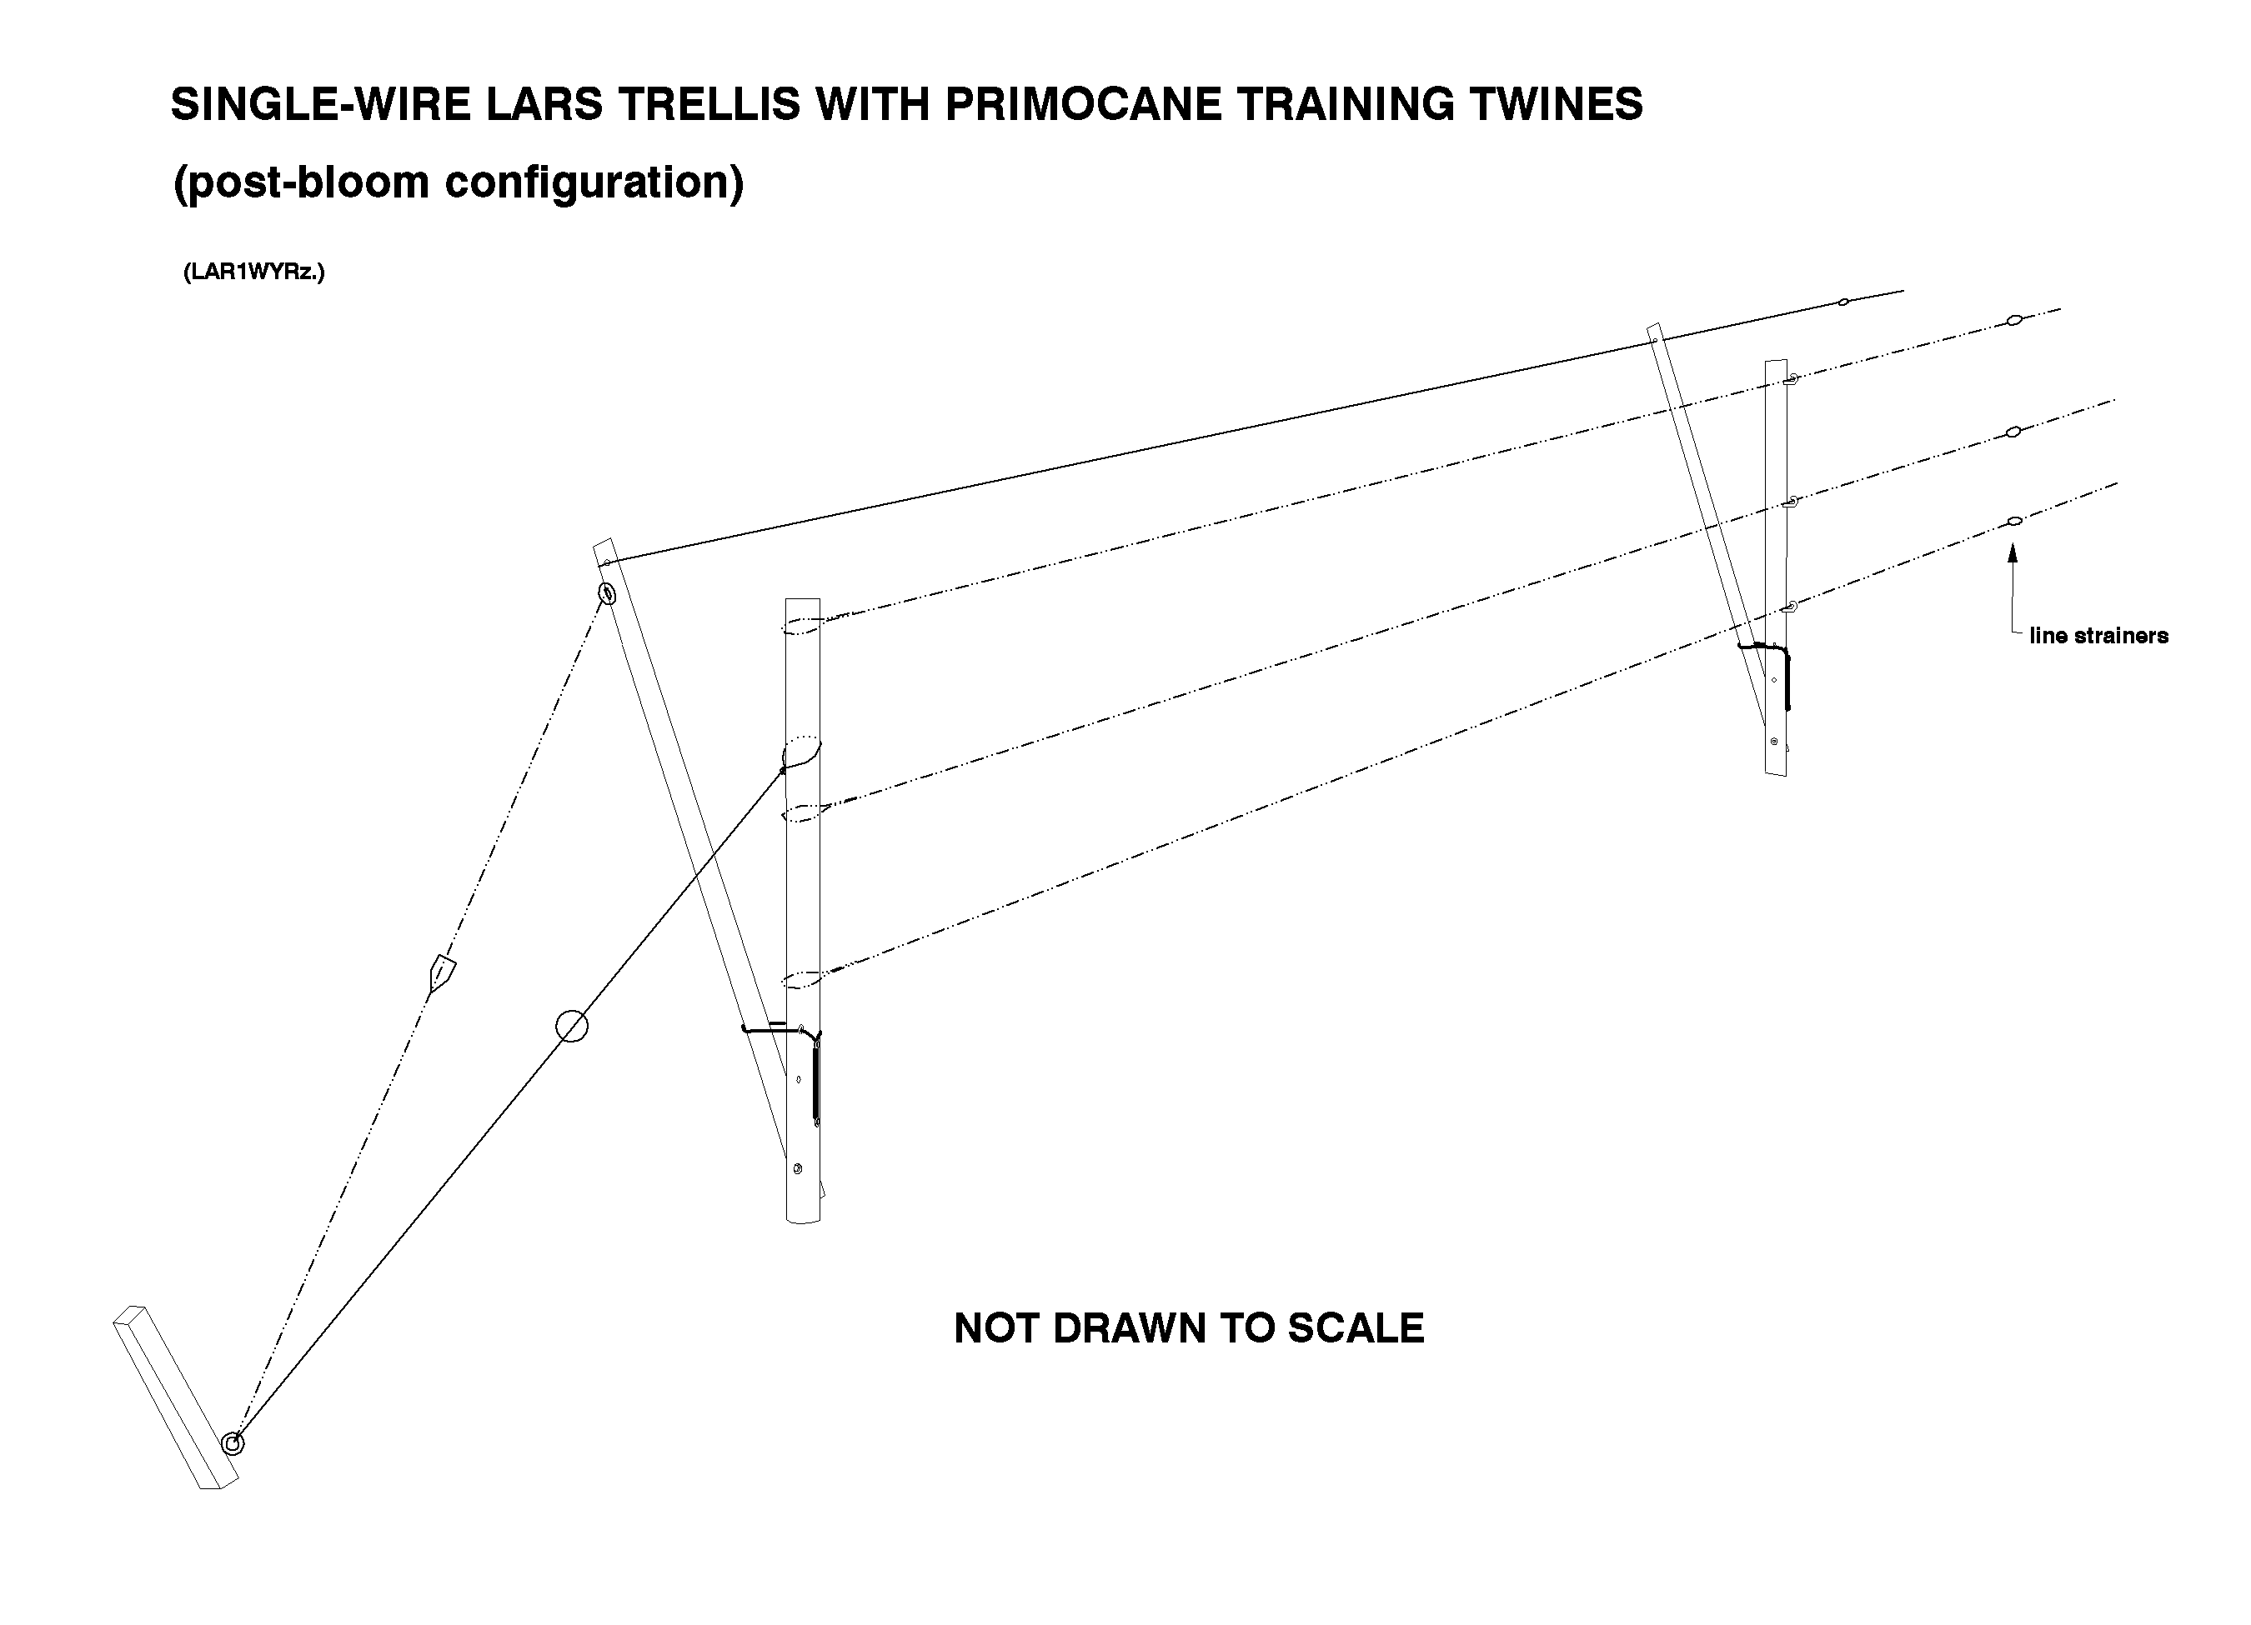
Figure A-1.
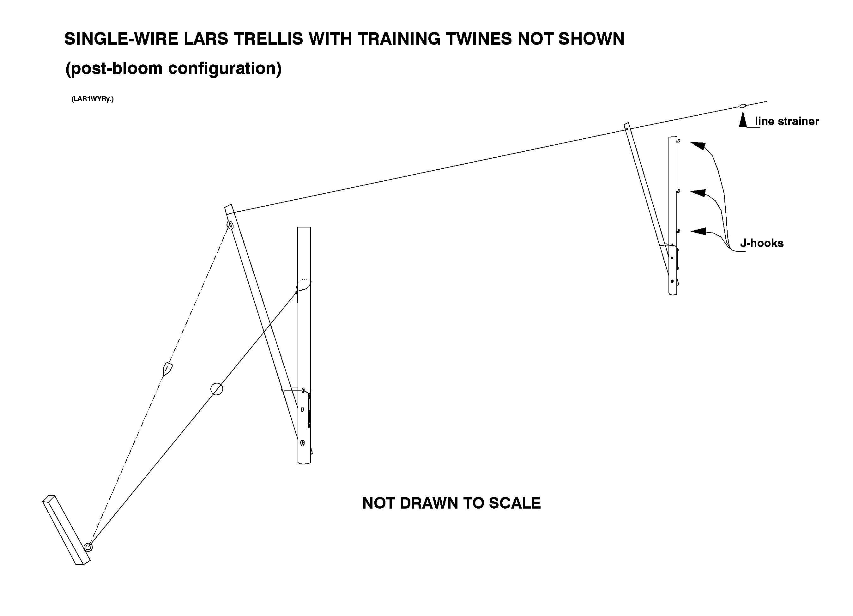
Figure A-2.
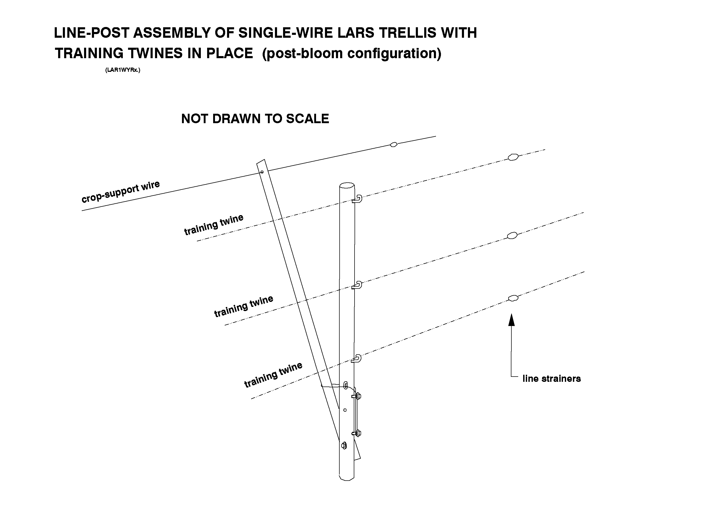
Figure A-3.

This table does not include materials for the associated "Primocane-Support Spar, see the latter in a subsequent listing.
This table does not include materials for the associated "Primocane-Support Spar, see the latter in a subsequent listing.
This does not include lengths of 12.5 ga. hi-tensile wire that are used as "brace-wires" within the "end-post assemblies."
Low-cost, standard (for 12.5 ga. wire) Gripple wire fastener/tensioning devices seem to function satisfactorily in 100' to 210' test plots of this trellis, and are used for purposes of cost estimation in this document. A special tool must be purchased for use in tightening the wires on which Gripples have been installed. For long rows, greater load capacity, and easier application of higher tension, the somewhat more expensive, zinc-coated, rachet-type, in-line strainers may be needed.
If "in-line strainers" are chosen as the tensioning devices, it will be necessary to purchase 3 additional Nicopress no. FW-2-3 compression sleeves for each strainer that is to be installed.
Note that the amount of wire listed for "Item No.20" includes the lengths that will be used in the endpost assemblies' braces.
See also the table "Bill of Materials for Primocane-Support Spars and Twine in 1 Acre of 210-Foot Rows."
The number of spars will be equal to the number of crop-support arms (i.e., one at each linepost and one in each endpost assembly). Four strands (or levels) of primocane-support twine are used in the current design, although 3 strands may be adequate. Whatever the number of primocane-support strands, their attachments to "spars" must occur at points that correspond to the "vertical configuration heights" of their equivalent crop-support wires. Lengths of individual primocane-support twines (including portions necessary for attachment to endposts' spars and to in-line/on-line tensioners) will be about 10 feet less than the trellised row's over-all length (tie-back post to tie-back post).
Dowels are straight rods that should be tightly embedded to a longitudinal depth of about 5" in the bases of the two-inch diameter wooden spars; the protruding 4" portions of these pins are to be fitted loosely into 1/2" to 9/16" diameter shafts that are drilled into the tops of vertical posts of each linepost and endpost assembly.
Approximately 30' of twine will be needed to install a double stranded anchor-line between the tie-back post and the primocane-support spar at each end of the row.
Note that the amount of wire listed for "Item No.20" includes the lengths that will be used in the endpost assemblies' braces.
See also the table "Items for installation of Primocane-Support Spars and Twine in 500-ft. Rows."
It may be necessary, for rows as long as these, to employ a heavier grade (i.e., stronger) twine than is specified in this example. Two in-line/on-line plastic strainers are already specified for tightening each strand of twine; install strainers so that each is located approximately 150' from its respective end-post's crop-support-arm.

